**MINISTRY OF EDUCATION AND SCIENCE OF**

THE KYRGYZ REPUBLIC

ALA-TOO INTERNATIONAL UNIVERSITY

ENGINEERING AND INFORMATICS FACULTY

COMPUTER SCIENCE DEPARTMENT

**NETWORKING MANAGEMENT FOR MICROCREDIT COMPANY**

DIPLOMA THESIS



**By** Abdraim Kenenbaev

**Thesis Supervisor:** Assoc.Prof.Dr. Imtiyaz Gulbarga

**Bishkek – February 5,2021**

MINISTRY OF EDUCATION AND SCIENCE OF

THE KYRGYZ REPUBLIC

ALA-TOO INTERNATIONAL UNIVERSITY

ENGINEERING AND INFORMATICS FACULTY

COMPUTER SCIENCE DEPARTMENT

**NETWORKING MANAGEMENT FOR MICROCREDIT COMPANY**



DIPLOMA THESIS

**By** Abdraim Kenenbaev

|  |  |
| --- | --- |
| Thesis Supervisor:  Assoc.Prof.Dr. Imtiyaz Gulbarga | Date:  February 5,2021 |
| Head of Department:  Dr. Selchuk Dzhankurt | Date:  February 5,2021 |

**Bishkek –February 5,2021**

ALA-TOO INTERNATIONAL UNIVERSITY

ENGINEERING AND INFORMATICS FACULTY

COMPUTER SCIENCE DEPARTMENT

**ABSTRACT**

Networking Management for microcredit company

By Abdraim Kenenbaev

DIPLOMA THESIS

The goal of this project is to facilitate the work of microcredit financial institutions and banks. This project will be fully supported on personal network devices and Android platforms. Our application will support three languages ​​such as English Kyrgyz Russian. Our application will be executed on the Android Studio application Also, our application will contain its own Web Internet version, which will contain the Cloud chat bot

This will be the first new introduced format of this application, which will facilitate as much as possible the work of microcredit financial structures as well as banks that will track and show graphs of all workers' employees will also show how many transactions were made in a given month In this period and will show the amount of charges for these transactions

**Key words:** Dictionary, Mob.App, Smartphones, Mathematical terminology, Android Studio

**Thesis Supervisor:** Assoc. Prof. Dr.Imtiyaz Gulbarga **Date:** February 5,2021

АЛА-ТОО ЭЛ АРАЛЫК УНИВЕРСИТЕТИ

ИНЖЕНЕРДИК ЖАНА ИНФОРМАТИКА ФАКУЛЬТЕТИ

ИНФОР МАТИКА ЖАНА ЭСЕПТӨӨ ТЕХНИКАСЫ КАФЕДРАСЫ

**АННОТАЦИЯ**

**Микрокредиттик компаниянын тармактык менеджери**

Аткарган Абдраим Кененбаев

ДИПЛОМДУК ИШ

Бул долбоор Банктардын жана микрокреддитик компаниялардын ишин женилдетуу ичин болот. Бул Программа андроид смартфонлор учун жана Компьютерлер учун 4. Бул программа тармактык шаймандар жана Android платформалары үчүн толугу менен жеткиликтүү болот Бул микрокредиттик каржы түзүмдөрүнүн, ошондой эле бардык жумушчулардын кызматкерлеринин графиктерин көзөмөлдөөчү жана көрсөтүүчү банктардын ишин мүмкүн болушунча жеңилдеткен ушул тиркеменин биринчи жаңы киргизилген форматы болот, ошондой эле канча транзакцияны көрсөтөт Ушул мезгилде бир айда жасалган жана ушул операциялар үчүн төлөмдөрдүн суммасын көрсөтөт

.

**Ачкыч Сɵздɵр:** Сөздук, Смартфон, Математикалык терминология, Андроид Студио

**Илимий Жетекчиси:** И.и.к., доц Иса Муслу **Датасы:** Июнь 4, 2021

МЕЖДУНАРОДНЫЙ УНИВЕРСИТЕТ АЛАТОО

ФАКУЛЬТЕТ ИНЖЕНЕРИИ И ИНФОРМАТИКИ

КАФЕДРА ИНФОРМАТИКИ И ВЫЧИСЛИТЕЛЬНОЙ ТЕХНИКИ

**АННОТАЦИЯ**

НАЗВАНИЕ ДИССЕРТАЦИИ

**Выполнил** Имя Фамилия

ДИПЛОМНАЯ РАБОТА

Цель данного проекта заключается в облегчении работы микрокредитных финансовых структур и банков . Данный проект будет полностью поддерживаться на персональных сетевых устройствах и на устройствах Android платформ Наше приложение Будет поддерживать три языка такие как английский кыргызский русский. Наше приложение будет выполнено на приложение Android Studio Также наше приложение будет содержать свою Web интернет версию в которой будет заключён чат-бот Облачный

Это будет первый новый введённый формат данного приложения которое будет облегчать максимально работу микрокредитных финансовых структур также банков который будет отслеживать и показывать графики всех рабочих сотрудников также будет показывать Сколько транзакций было совершено в данном месяце В данный период и будет показывать сумму начислений данных транзакций

**Ключевые Слова:** Словарь, Моб.Приложения, Сматрфон, Математические терминологии, Андроид Студио

**Научный Руководитель:** К.и.н., доц Иса Муслу  **Дата:** Июнь 4, 2021

# TABLE OF CONTENTS

**Contents**

TABLE OF CONTENTS **5**

LIST OF FIGURES **7**

LIST OF TABLES **8**

LIST OF ABBREVIATIONS **9**

ACKNOWLEDGEMENTS **10**

INTRODUCTION **1**

CHAPTER 1 **2**

BACKGROUND AND LITERATURE REVIEW **2**

Research Objectives and Approach(Heading 2) 3

Scope of the Application(Heading 2) 3

Features of the Project 3

Subtitle 2 (Heading 3) 3

Goal of the project 4

Equations 4

Figures 4

Tables 6

METHODOLOGY **7**

Amvm Knv 8

CHAPTER 3 **9**

TECHNICAL REQUIREMENTS **9**

Subtitle 1 9

CHAPTER 4 **10**

RESULTS **10**

Subtitle 1 10

Subtitle 1 10

Subtitle 2 10

CONCLUSION **11**

REFERENCES **11**

1

# LIST OF FIGURES

Figure 1.1: DNdw Annwdnf 6

Figure 1.2: Example photo with high resolution. Caption created with “insert, reference, caption, figure” and the style changed to “thesis-figure caption.” 6

# LIST OF TABLES

Table 1-1: Steps in creating a table d7

Table 2-1: Styles used in this template 8

# LIST OF ABBREVIATIONS

# ACKNOWLEDGEMENTS

0

This project will be an analogue of the OBC system that will operate throughout Kyrgyzstan and will be offered as a commercial proposal for all microfinance and banking structures of Kyrgyzstan

This application will be offered to all buyers on a turnkey basis, which implies an Android-based application and your personal website that will contain the entire customer database and their payment schedules and transactions made by them for a certain period

**February 8, 2021**

**Abdraim Kenenbaev**

# INTRODUCTION

In my opinion, for research reasons, at the moment in the Kyrgyz Republic about 95% of microcredit companies, the financial structure and banks do not have one common proposal that could send reports to the National Bank of the Kyrgyz Republic, everything needs a separate writing of different reports and at the same time it will be possible to send different reports to the stomach to different mails, that is, What does it mean the incompetent work of certain financial structures or banks for this and our application is created, which will also contain a report button that will automatically send all reports for 2021 and 2022 to the National Bank of the Kyrgyz Republic. Foreign countries have long seen and as an example given one way or another different crm-systems and all other proposals that help to facilitate the work of financial structures and banks as much as possible, that is, What gives certain access and greatly facilitates their work

Also, in addition to this, our application will contain completely all laws introduced by the national bank of the Kyrgyz Republic for certain microcredit institutions or a bank There are also styles for headers, equations, captions and bulleted lists that you can choose to use. See examples throughout this template.

# CHAPTER 1

# BACKGROUND AND LITERATURE REVIEW

The background and literature review section needs to provide sufficient fundamental background information about the subject to support your objectives, hypothesis (or research questions) and methods, and review the pertinent literature related to the specific problem / hypothesis you are addressing. In Johnson (1991), some of the questions that he listed that the literature review should be to answer include:

* what are the fundamental science, math, engineering concepts related to your research (scope),
* what part of your research work has ever been investigated before and what has not, (some of this may have been included in the introduction)
* how does your research work relate to that done by others,
* how have others defined/measured/identified the key concepts of your research,
* what data sources have you used or have other researchers used in developing general explanations for observed variations in a behavior or phenomenon in a concept in your thesis etc.

The lit review (~20 pages or more) should not be limited to the above questions only. Ingeniousness and creativity is expected of a grad student.

Bullets can be single-spaced. The above bullets are in the style “thesis-bullets.” When you type bulleted text, highlight the bulleted text and then select “thesis-bullets” from under the format, style menu to automatically change their formatting as above.

## Research Objectives and Approach(Heading 2)

## Scope of the Application(Heading 2)

Given the length of each chapter, it is required to use titles and subtitles (possibly sub-sub titles). These can be numbered or one can just rely on different formats. The section titles in this document are labeled “heading 2” (“heading 1” was used for chapter titles). The heading styles formats should be consistent throughout the document as it helps significantly in creating the automatic table of contents.

## Features of the Project

### Subtitle 2 (Heading 3)

The subtitles here have a different format (“heading 3”) than the section titles.

## Goal of the project

You can even get to another level of headers, defined here as “heading 4.” The table of contents, however, is currently set up to just include three levels of headers.

### Equations

Equations can be created in MS WORD equation editor or they can be created with other software. Equations should be numbered. They can be numbered within each chapter (e.g., 2.1, 2.2) or they can be numbered sequentially throughout the entire thesis. Equations should be indented or centered with the equation number to the right. The example below and associated “thesis-eqn” style can be used for all your equations.

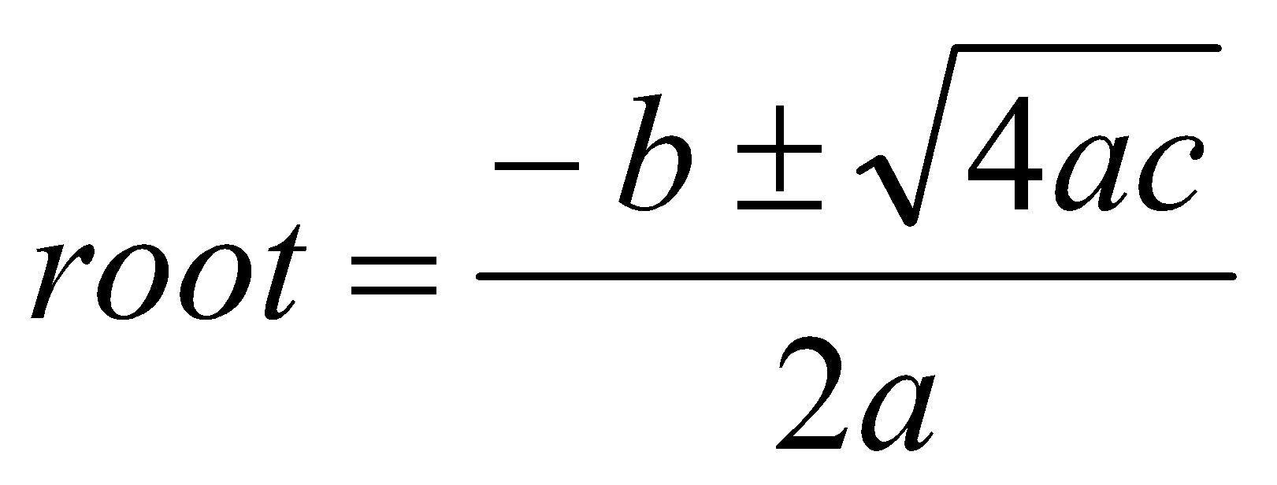 [1]

This equation was written with the equation editor. Found through “insert, object, and equation editor 3.0. The equation editor can also be found through “tools, customize, commands”, and in categories, look for insert and in the commands section, look for equation editor, drag and drop the icon onto the toolbar. This editor is fine for relatively simple equations, other options are available for more complex equations.

### Figures

Figures and illustrations are a necessary means of communicating technical information. Often times, figures included in the background/lit review section are copied from existing copyrighted information. In all cases, this is technically inappropriate without also receiving permission from the copyright owner. Citing the source of the figure is not sufficient. This rule is enforced for PhD dissertations because they are submitted to ProQuest for electronic access by others. The enforcement of this rule for MS theses is dependent on the specific committee members.

Resolution of figures is often a problem in theses. Resolution should be >300 dpi, preferably 600dpi (**Error! Reference source not found.**). You should note that saving images as jpeg files is a sure way to lower the resolution to an unacceptable extent. From experience, a good way is to copy your graphic (for example from PowerPoint or excel) and when pasting it into word, use the “paste special” “as an “enhanced metafile” (**Error! Reference source not found.**). This also substantially reduces the resulting file size in comparison with pasting graphs in as excel graphics.

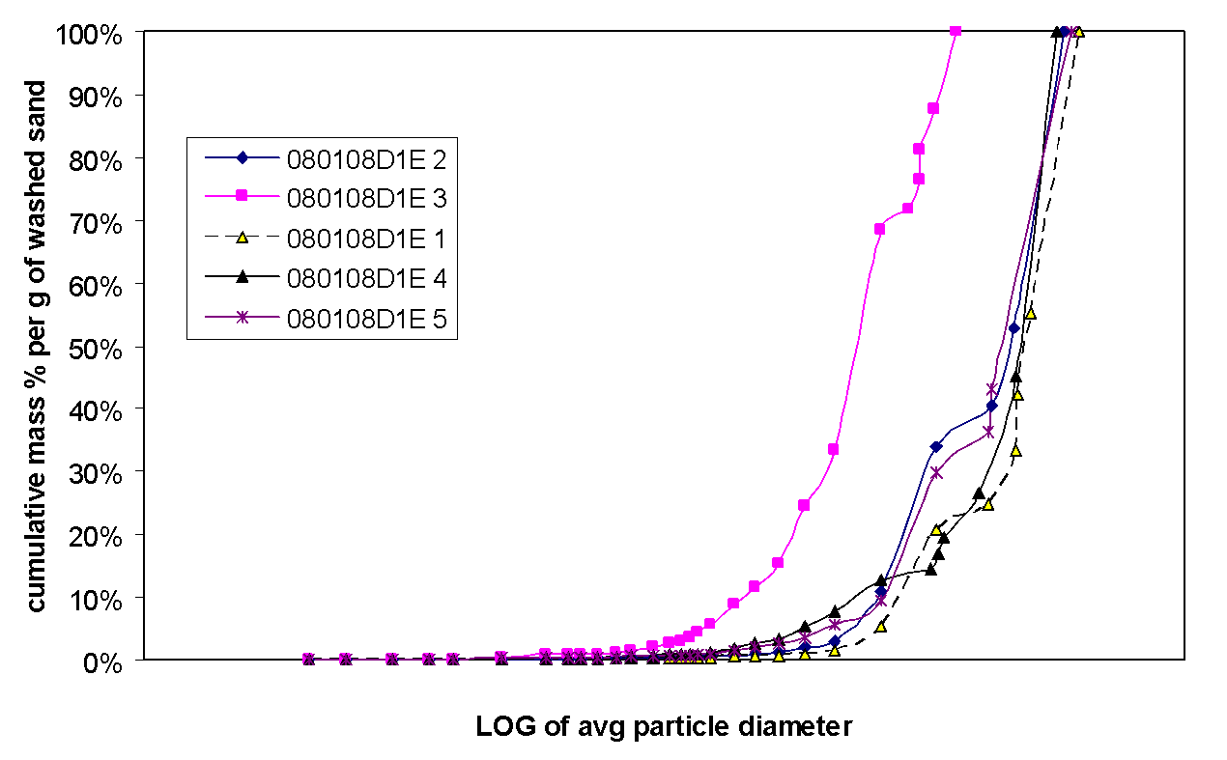

**Figure 1.1: DNdw Annwdnf**

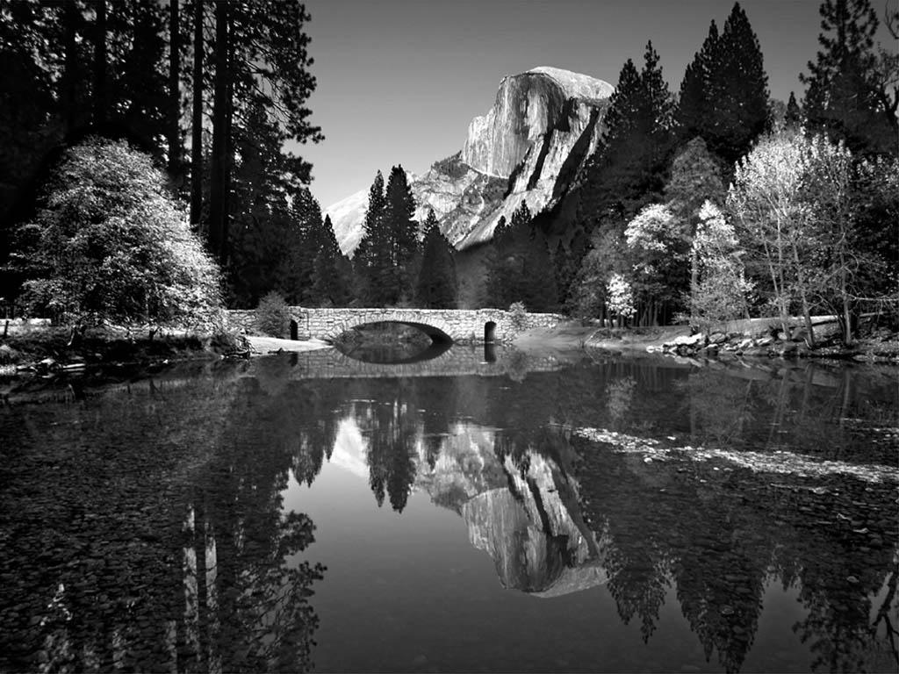

**Figure 1.2: Example photo with high resolution. Caption created with “insert, reference, caption, figure” and the style changed to “thesis-figure caption.”**

### Tables

Tables should have meaningful information with descriptive headers. You can use the “thesis-table caption” style to define your captions and refer to the table in the text with a “cross reference” (**Error! Reference source not found.**). MS Word re-numbers table captions automatically when new tables inserted. Nevertheless, you need to right click on any cross references and “update field” if there are changes.

**Table 1-1: Steps in creating a table**

|  |  |
| --- | --- |
| **Step #** | **Instruction** |
| Create table caption | Insert, reference, caption, table |
| Format the caption | Format, style, “thesis-table-caption” |
| Create table | Table, insert… |
| Format the table | The formatting of the table can vary, including use of single space as appropriate. Most journals require that tables are formatted using table style “Table Simple 1” format. |
| Reference the table from the text | With the cursor at the location you want to cite the table: insert, reference, cross reference, table, label and number only. |

**CHAPTER 2**

# TECHNICAL AND ANALYTICAL EVALUATION

In addition to the detailed methods you need to describe in this section, you need to provide specific objectives and an overview of your approach if they have not already been presented in the introductory chapters. The best place to put those items can vary among theses. Sometimes the background and lit review is really necessary to justify and substantiate the specific objectives and approach and, therefore, it is best to save those details for the beginning of this chapter.

These paragraphs are in “thesis-body text.” Other styles including captions, headers etc. can be used as presented in the previous chapter. **Error! Reference source not found.** summarizes all of the styles that can be used with this template.

**Table 2-1: Styles used in this template**

|  |  |
| --- | --- |
| Style name | When used |
| Heading 1 | Chapter titles |
| Heading 2 | Primary headers |
| Heading 3 | Sub headers |
| Heading4 | Sub-sub headers |
| Thesis-body text | All paragraphs |
| Thesis-bullets | Bullets |
| Thesis Figure caption | All figure captions. |
| Thesis table caption | All table captions |
| Thesis-eqn | equations |
| Thesis-reference | Reference list at end of thesis |

## Amvm Knv

# CHAPTER 3

# [SYSTEM ARCHITECTURE AND DESIGN](https://docs.google.com/document/d/1sW3b9G86zITqqq4agsjDn4AgfZhTFyvqYkm--NJ1jso/edit" \l "heading=h.2dlolyb)

Results, findings, discussion of results OR manuscripts. It is best to also reiterate information in your literature review to help substantiate the findings of your research.

This template is best used for directly typing in your content.

## Subtitle 1

# CHAPTER 4

# RESULTS

## Subtitle 1

## Subtitle 1

### Subtitle 2

# CONCLUSION

This chapter could also be called “Conclusions and Recommendations” or “Conclusions and Implications.” In general, there should be no new information presented here. It should be a synthesis of information that you have already discussed.

# REFERENCES

Includes all references: articles, media facts, books, reports, regulations, internet articles, papers that you referenced from the text. In the text, citations can be (Smith and Jones, 2007) or Smith et al., 2007) (if more than two authors) if you wish to present your references alphabetically. Alternatively, you can include the citations in the text as a number [1] or 1 if you wish to present your references numerically. The computer software “End Notes” (Alatoo doesn’t have a site license) or the MS WORD tools – “insert, reference, footnote, endnote” (or “cross reference” if you refer to the same reference more than once) should be used to help you organize and manage your references.

References can be written in single space with extra space between references as in the format below. There are many different ways to arrange the information and punctuation in a reference listing. The most important thing is to make sure all references are complete and that the format of your references is consistent throughout.

Example, S.Z. (2008). How to cite a complete journal reference. *J. Complete Thesis*. 1(2): 47-52.

Example, S.Z., Second, W.S. (2007). How to cite a complete conference proceedings paper. In: *Proceedings*, 2nd International meeting of Masters Students, Paper # XW15 (Potsdam NY, November, 2007).

**Appendix A**

Type or paste your appendices here. Appendices are a place to organize and include all of the “extra” material that is important to your research work but that is too detailed for the main text. Examples can include specific analytical methods, computer code, spreadsheets of data, details of statistical analyses, etc. Nevertheless, these materials do not speak for themselves. There should be a reference to these materials from the main chapters (complete details included in Appendix A) and there should be some text at the beginning of each appendix to briefly explain what the information is and means that is included in that appendix.